 | BREAKFAST | SNACK | LUNCH | SNACK
MONDAY | Oatmeal  and strawberries  with milk | Apples and crackers | Turkey & cheese on wheat  tomatoes and carrots  with milk | Yogurt and granola
TUESDAY | Cheerios and bananas  with milk | Pretzels and kiwi | Vegetable beef soup,  and biscuits  with milk | Animal crackers and  applesauce
WEDNESDAY | Toast and peaches  with milk | Goldfish and cherry  tomatoes | Tuna sandwich  celery and carrots  with milk | Cottage cheese and pears
THURSDAY | Biscuits and apples  with milk | Yogurt and granola | Eggs and toast with onions  and peppers  with milk | Triscuits and pineapple
FRIDAY | Waffles and blue berries  with milk | Fruit salad  and cheese | Chicken nuggets &  garlic bread, mixed veggies  with milk | Carrots and gram crackers
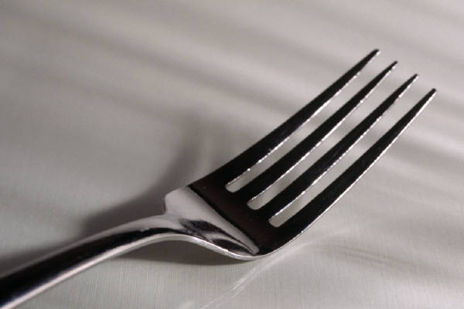
FOOTPRINTS MENU

